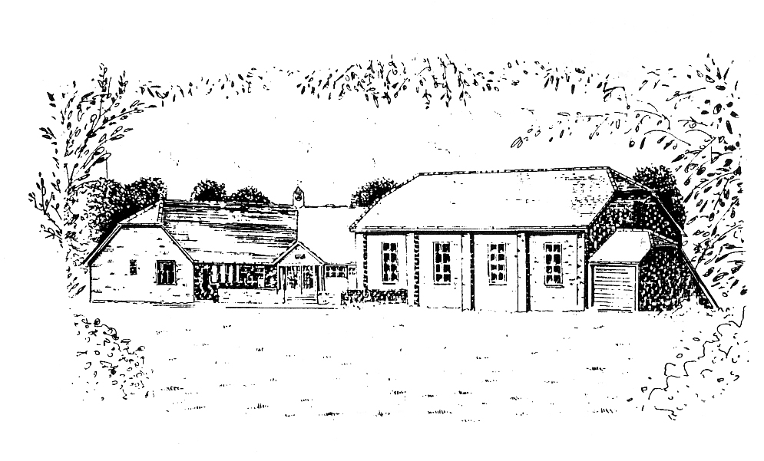Turners Hill Parish Council

The Ark

Mount Lane

Turners Hill

West Sussex RH10 4RA

01342 712226

office@turnershillparishcouncil.gov.uk

www.turnershillparishcouncil.gov.uk

**GRANT APPLICATION FORM**

Applicants are advised that this form and the information supplied with it will be included as part of the Parish Council’s public records.

Applicants should read the Grant Funding Policy before completing this form.

Please submit any supporting information requested at the same time as submitting this form.

|  |  |
| --- | --- |
| **Contact Details** | |
| Name of applicant | Click or tap here to enter text. |
| Address of applicant/organisation | Click or tap here to enter text. |
| Position in organisation | Click or tap here to enter text. |
| Name of organisation | Click or tap here to enter text. |
| Address where activities are based | Click or tap here to enter text. |
| Telephone number | Click or tap here to enter text. |
| Email address | Click or tap here to enter text. |
|  |  |
| **Project Information** | |
| Aim of organisation | Click or tap here to enter text. |
| Amount of grant applied for | Click or tap here to enter text. |
| Total cost of project | Click or tap here to enter text. |
| Other funding received | Click or tap here to enter text. |
| Describe your project | Click or tap here to enter text. |
| What are the benefits for residents | Click or tap here to enter text. |
| What fundraising activities do you undertake | Click or tap here to enter text. |
|  |  |
| **Membership** | |
| How many people are involved in your organisation | Click or tap here to enter text. |
| Approximate % who are resident in Turners Hill | Click or tap here to enter text. |
|  |  |
| **Financial – information to attach** | |
| Have you attached accounts for the previous financial year (or a budget/business plan) | Yes |
| Have you attached a bank statement in the name of the organisation applying for the grant | Yes |
| Have you confirmed the bank details for where this grant should be paid | Yes |

I confirm that the above information is true to the best of my knowledge and belief, and that I am authorised to make this application.

|  |  |  |  |
| --- | --- | --- | --- |
| Signed | Click or tap here to enter text. | Date | Click or tap to enter a date. |

*If completing this form electronically, please just type your name*

Please return your completed application and supporting documents to [office@turnershillparishcouncil.gov.uk](mailto:office@turnershillparishcouncil.gov.uk), or by post to:

Turners Hill Parish Council

The Ark

Mount Lane

Turners Hill

RH10 4RA